**Estimation of Business Expenses**

**Submitted by**

**Team id**

**NM2023TMID20011**

**Team members id**

1.Sonakshi.M 02A07E35FB74C27960E44B91ECC0639C

2.Rajeshwari S 82B5558AFCAB7A499D74F399F0DF5AAC

3.Rohini S A44DB46D9CFF16CA55E4129A0795F56B

4.Sherin Fathima S 78A6ACB5718D0EFBAFA47B50C89A316A

Under the guidance of

**Dr. K. Lilly Mary Eucharista**

**Assistant Professor**

**Department of Physics**

**Sri Meenakshi Government Arts College for Women (A)**

**Madurai – 625 002**



**October 2023**

**Sri Meenakshi Government Arts College for Women (A)**

**Madurai – 625 002**

**Overview**

This report deal's into the fascinating realm of business expenses and provides a visual exploration of the various expenditures incurred by different businesses. It showcases the distribution of expenses, identifies key cost drivers, and highlights areas of potential optimization or concern. The visual representations allow for intuitive analysis, facilitating a deeper understanding of expenditure patterns and their implications for business performance. Decision-makers, financial analysts, and stakeholders can gain valuable insights into the financial health of businesses, identify areas of inefficiency or opportunity, and make informed decisions to optimize resources and drive growth. To Extract the Insights from the data and put the data in the form of visualizations, Dashboards and Story we employed Tableau tool.

**Purpose**

* Estimates are documents that provide approximate costs for a project.
* Freshbooks has an estimates feature that help you build an estimate quickly and easily.
* Advertising and Marketing
* Bank fees and Interest
* Business mileage
* Commissions
* Employee benefits

**PROBLEM DEFINITION & DESIGN THIINKING**

**2.1Empathy Map**

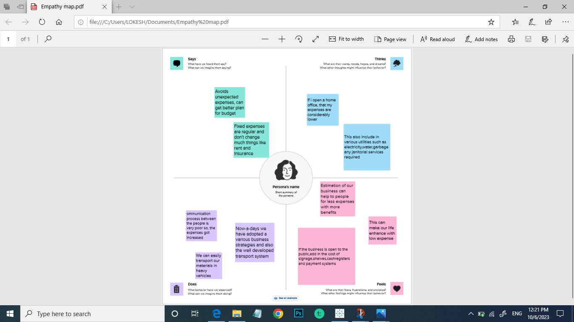

**2.2 Ideation and Brainstorming Map**

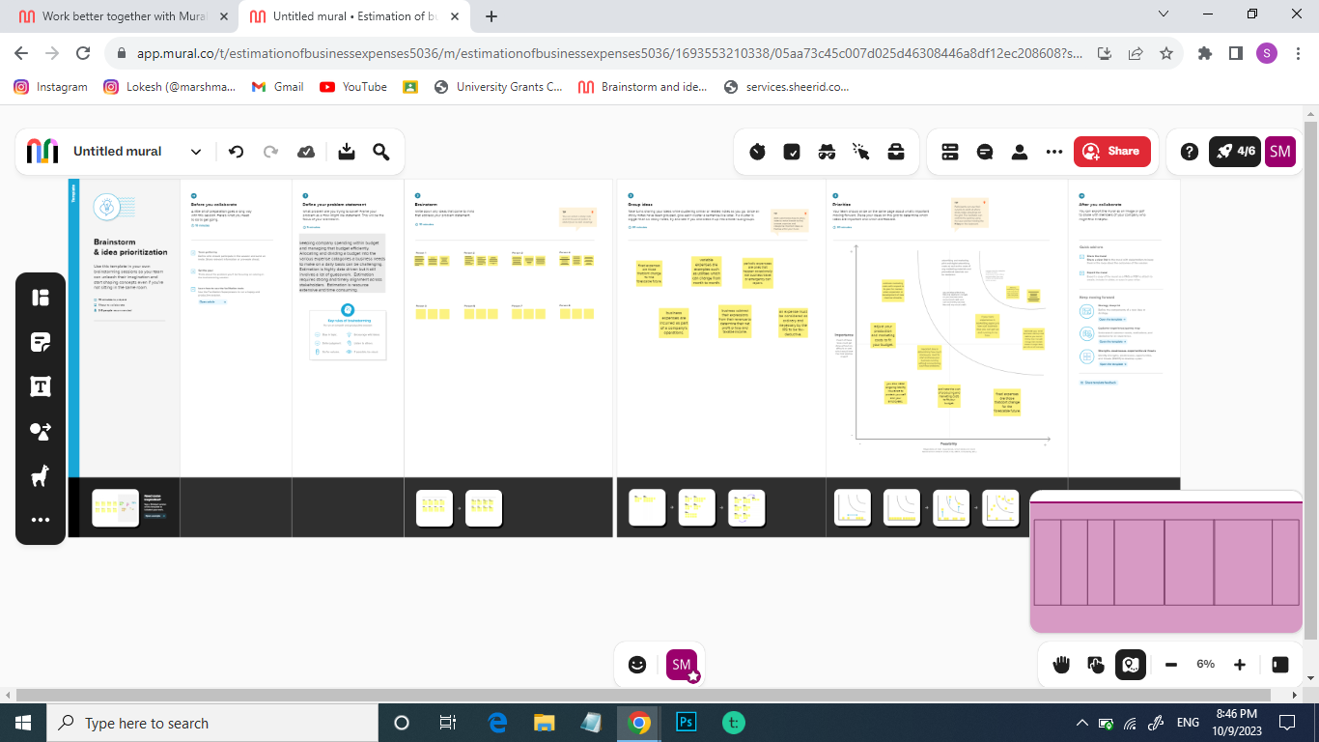

**RESULT**

**Visualization of Screenshots**

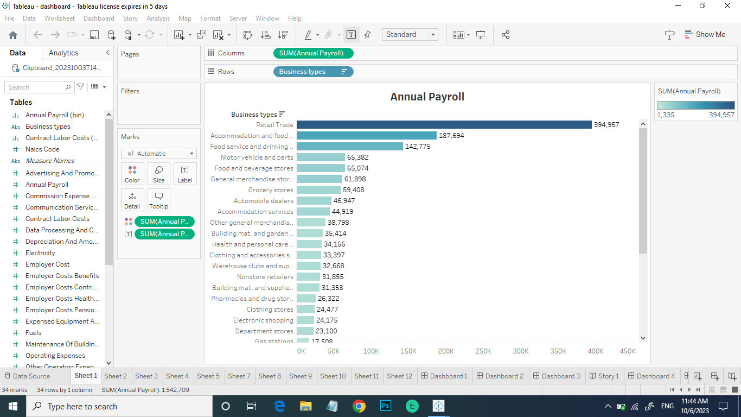

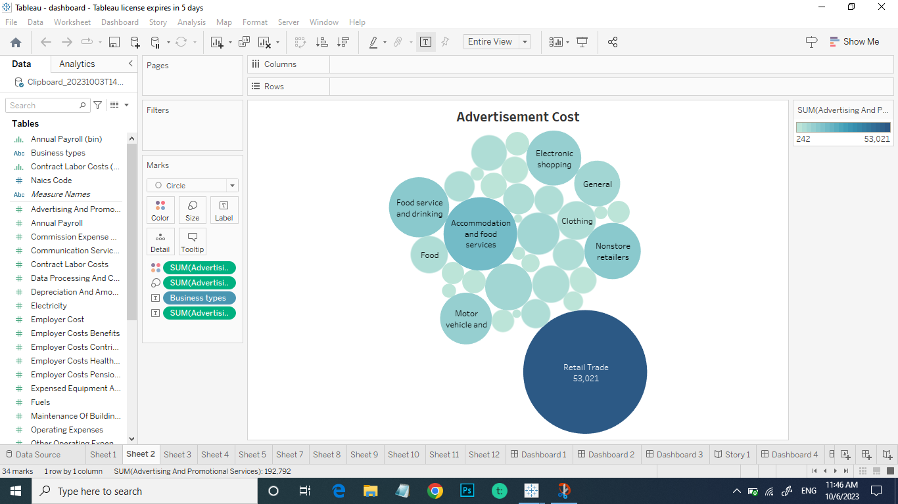

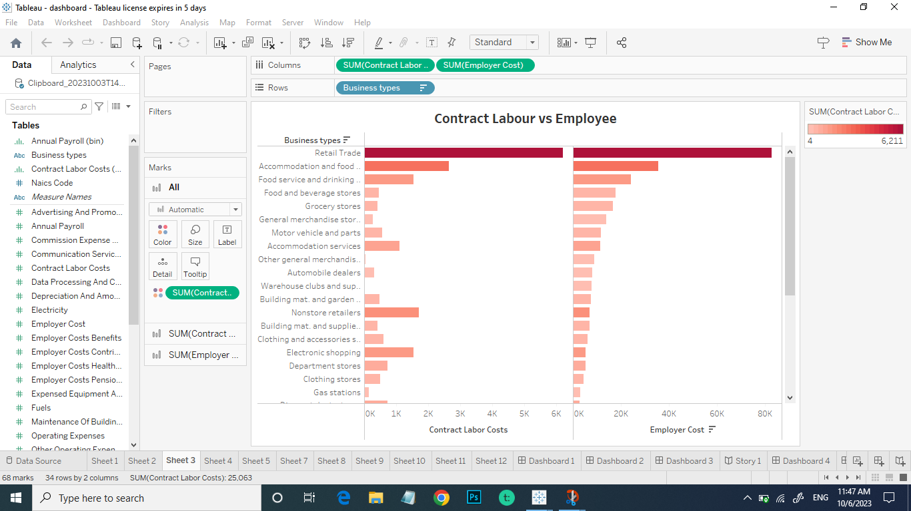

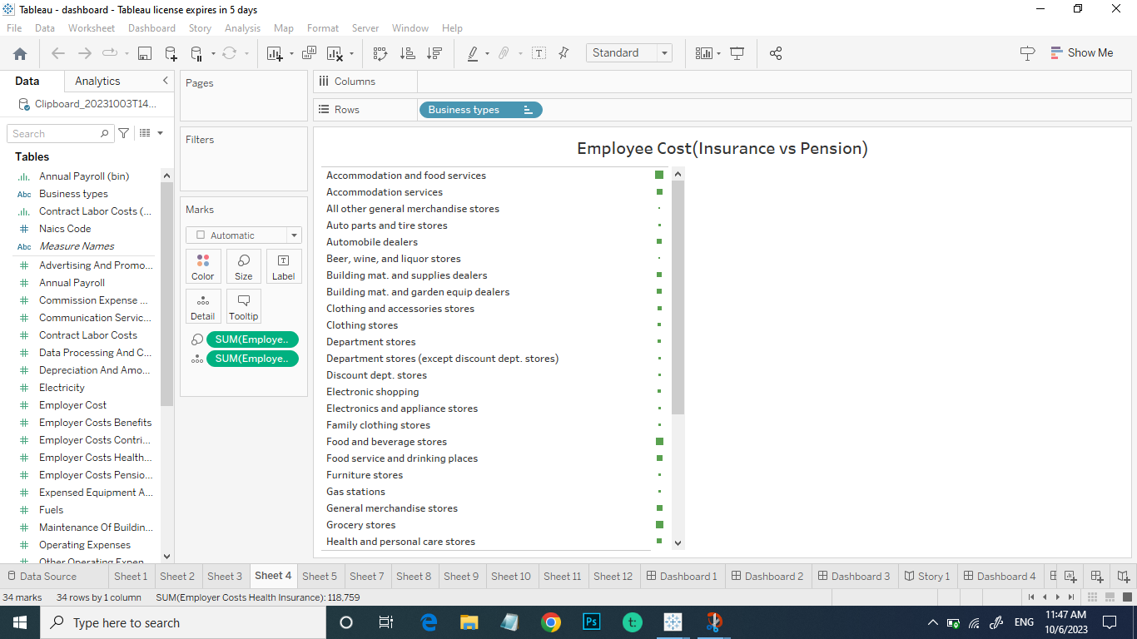

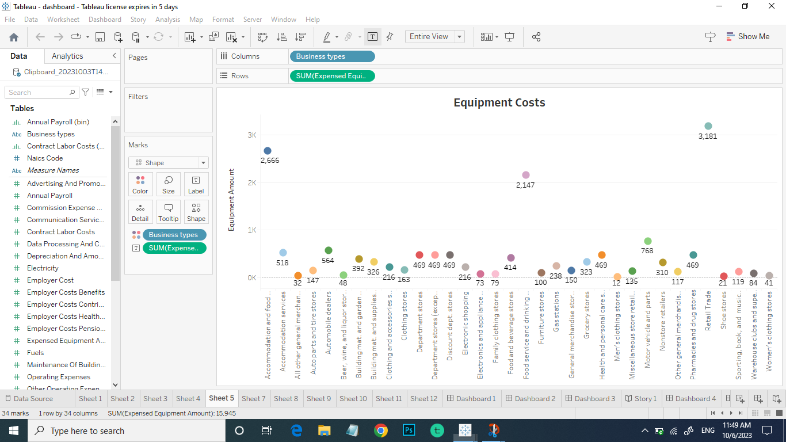

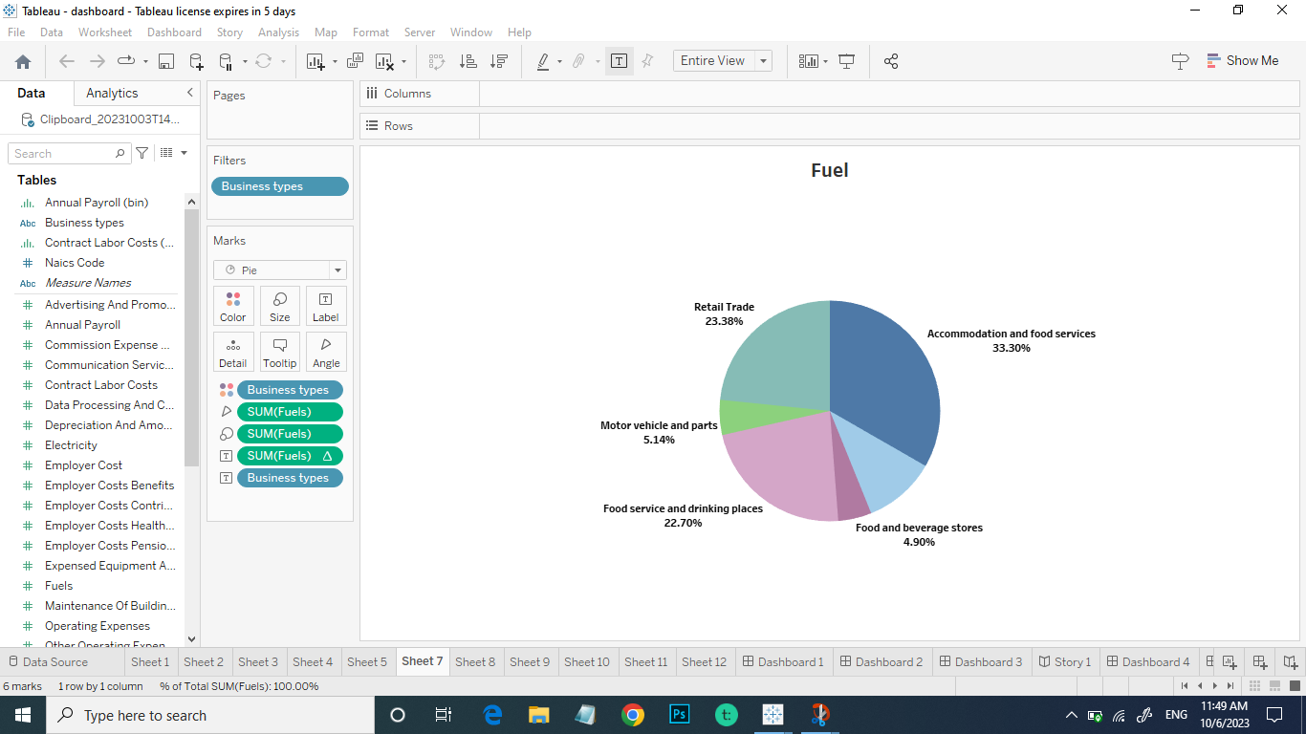

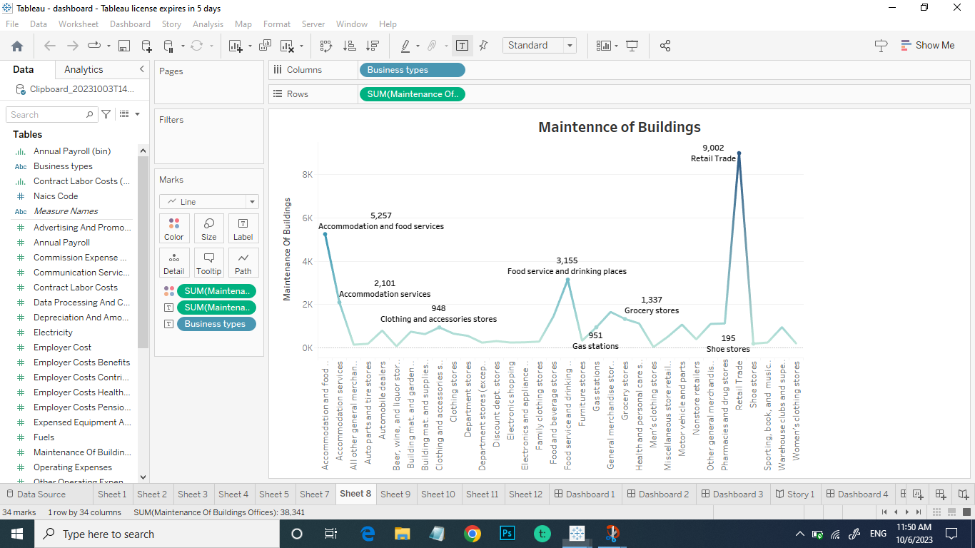

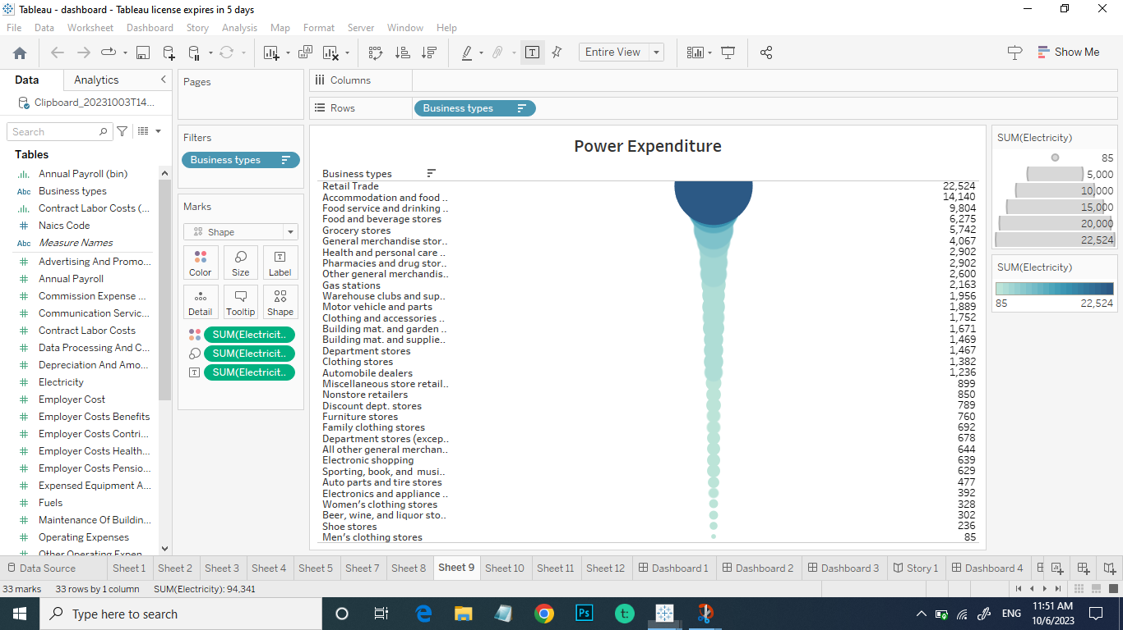

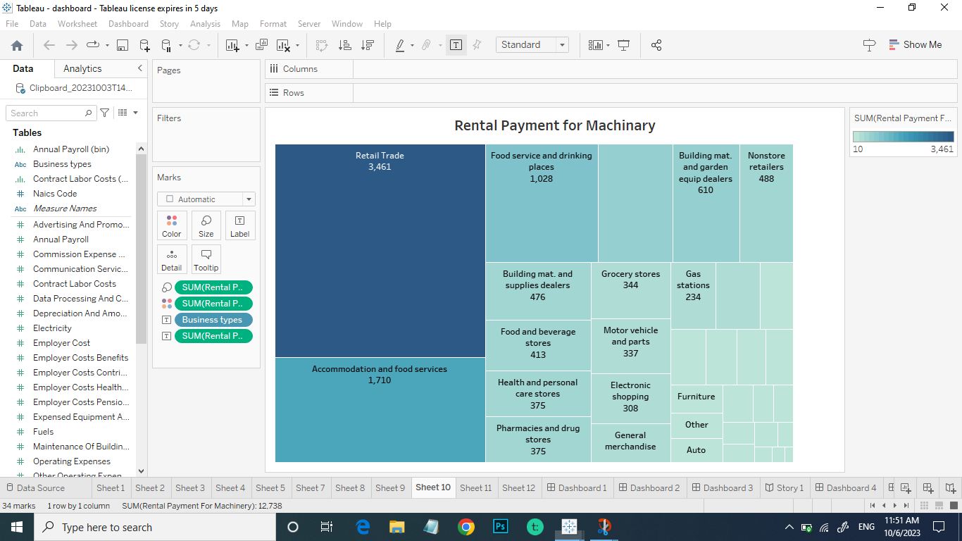

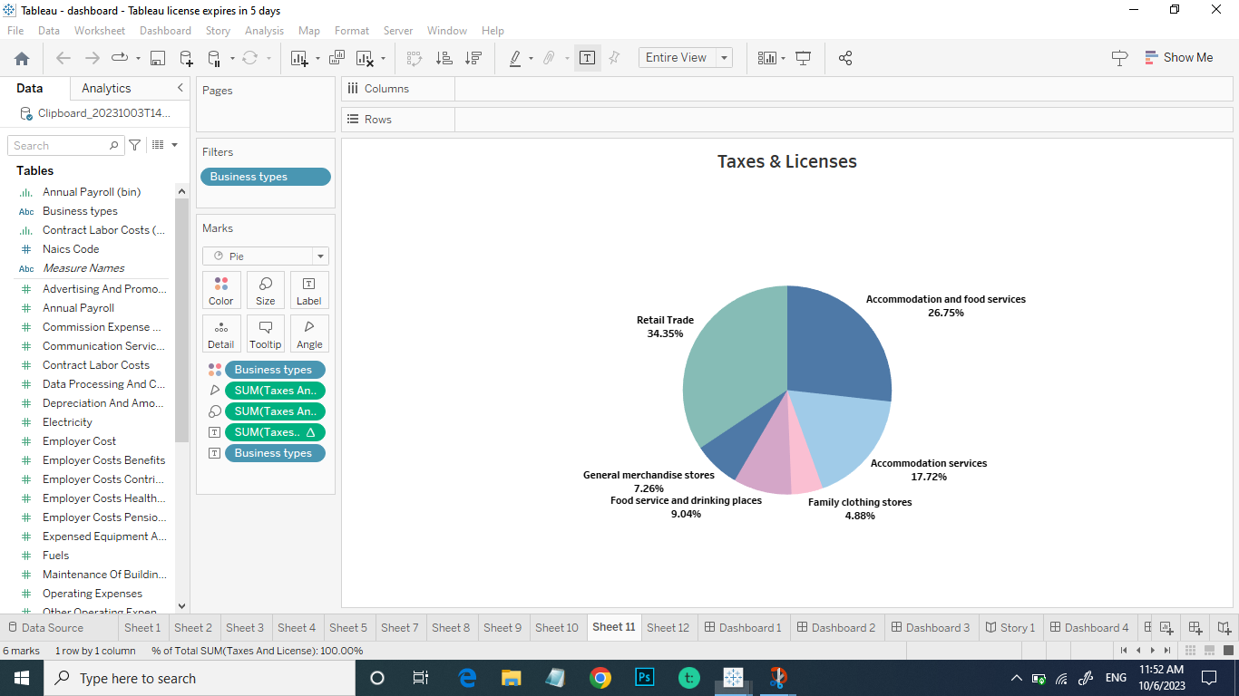

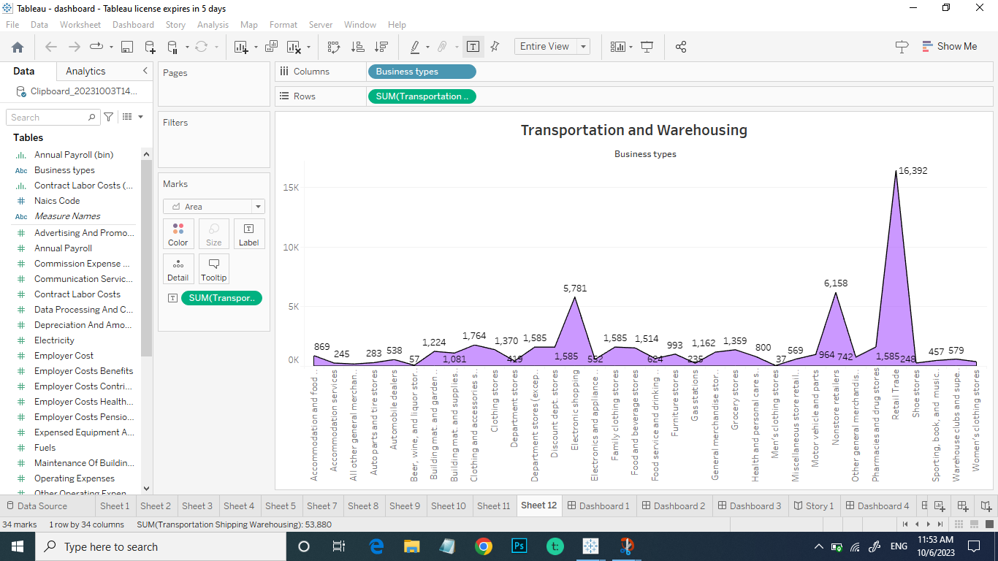

**Dashboard Screenshots**

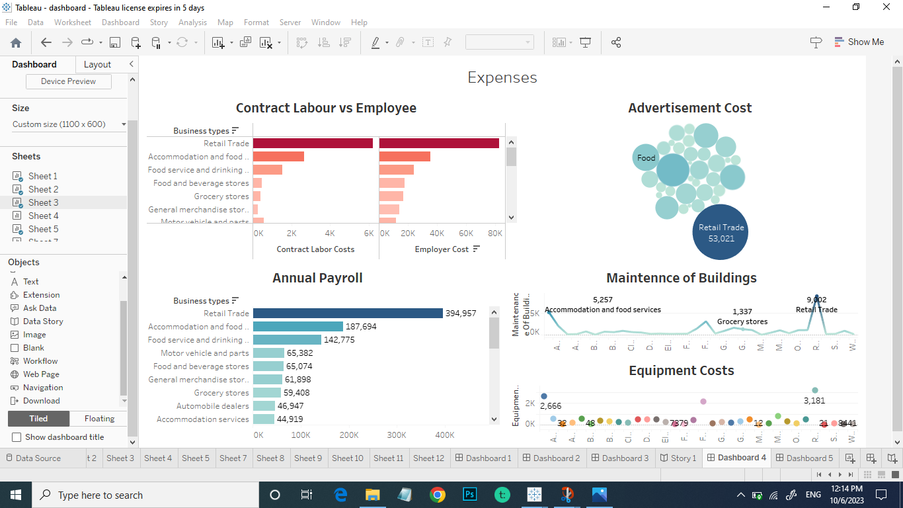

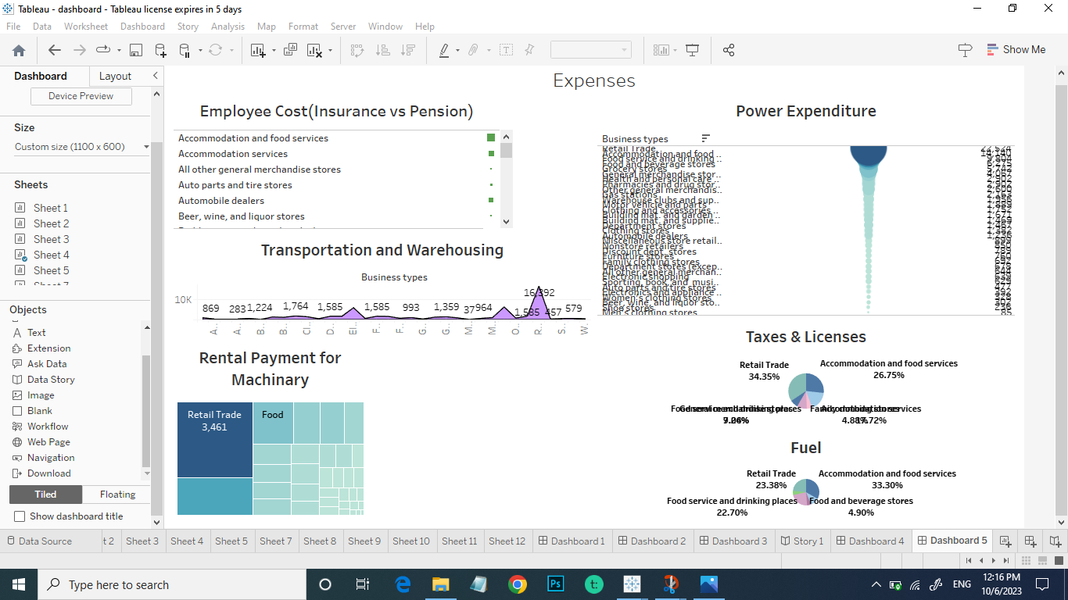

**Story Screenshots**

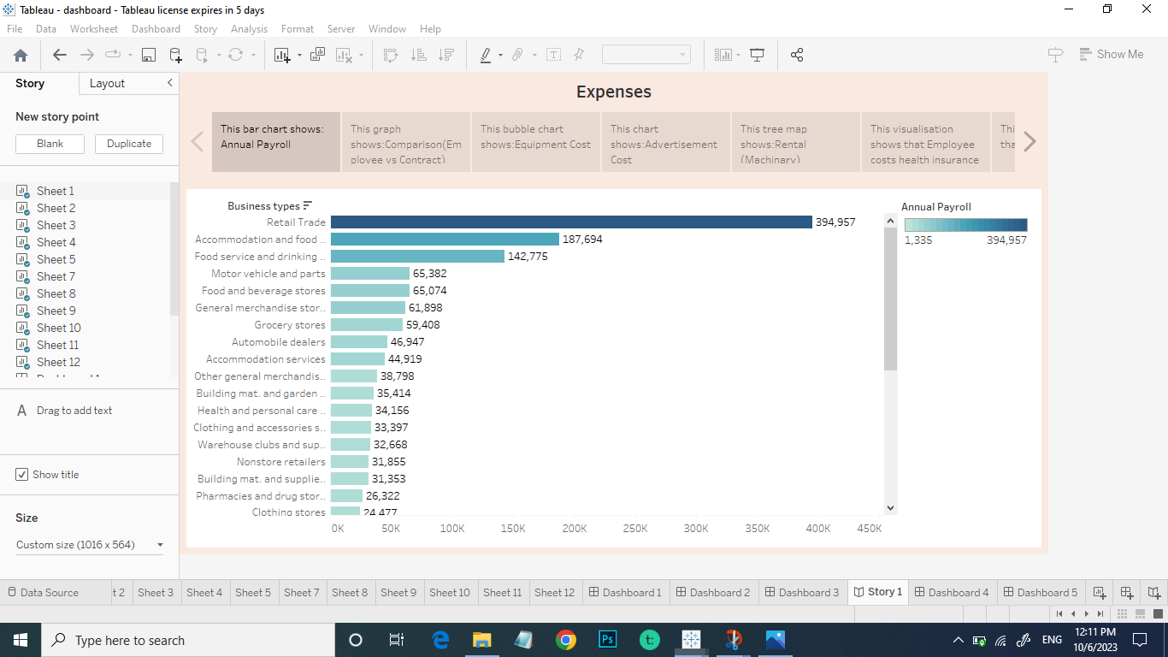

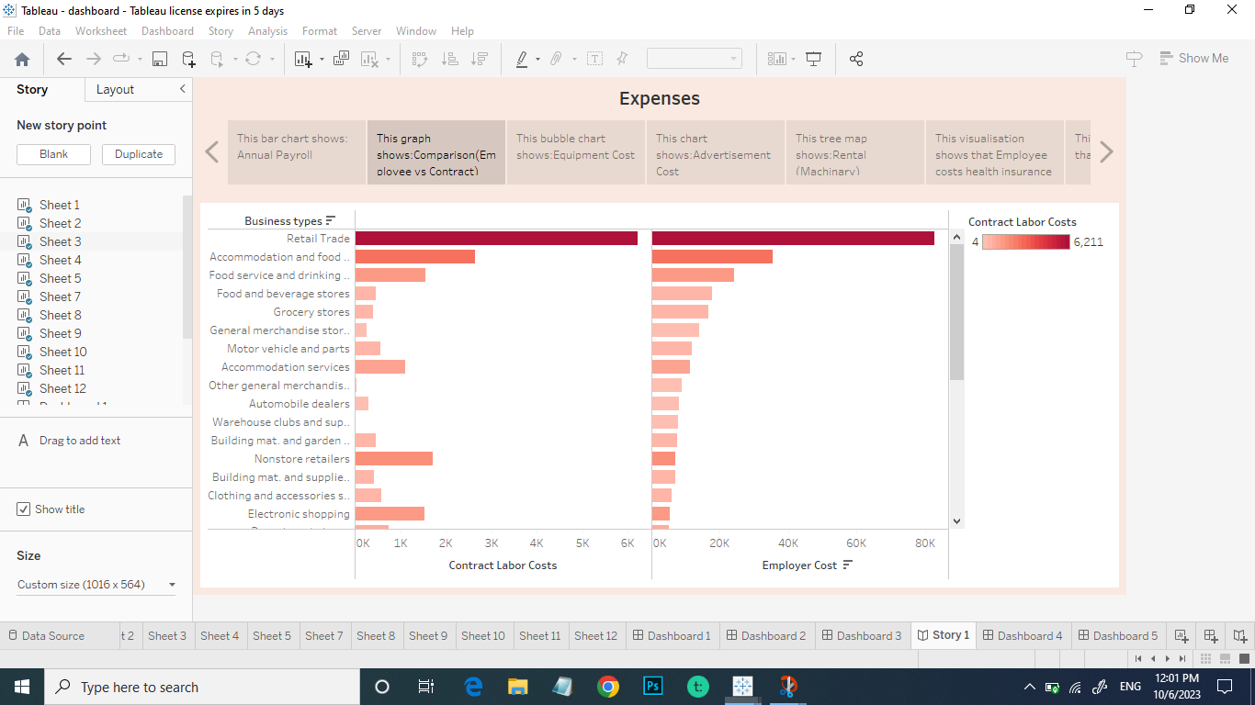

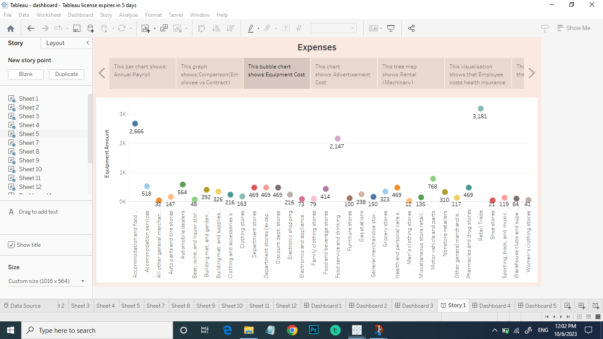

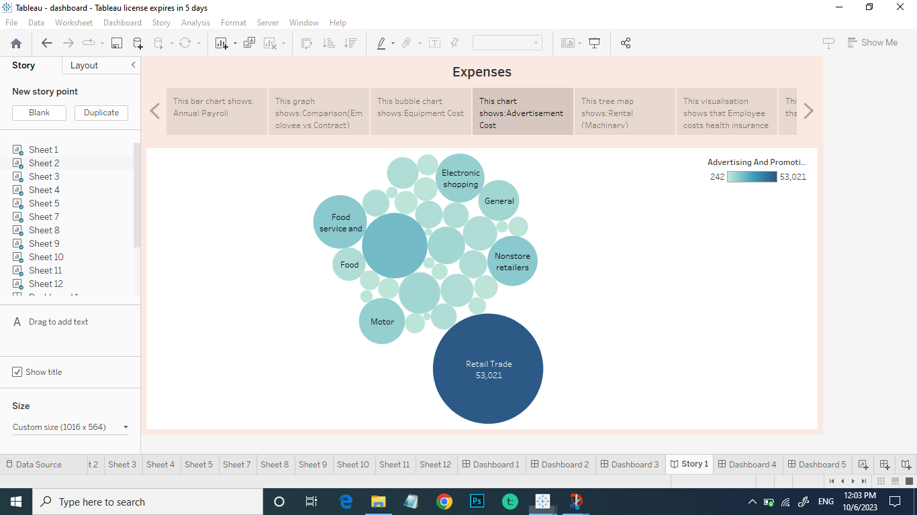

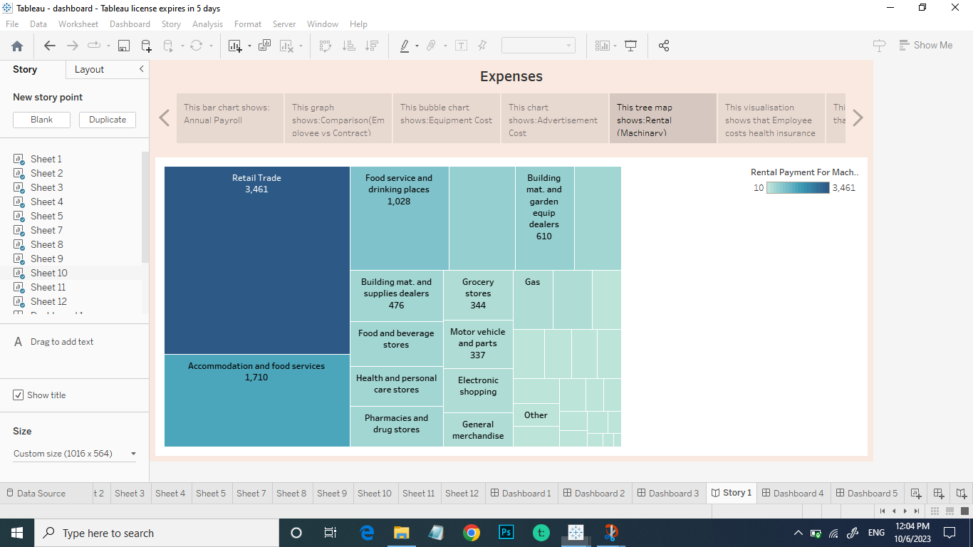

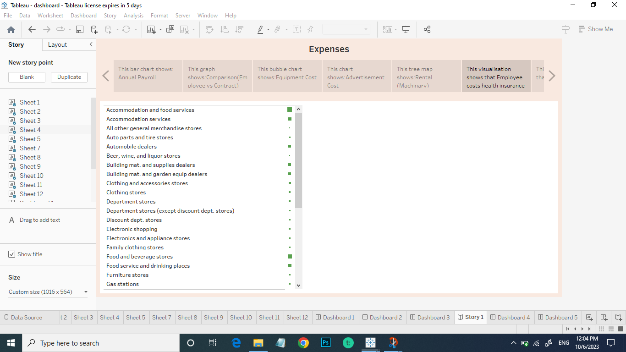

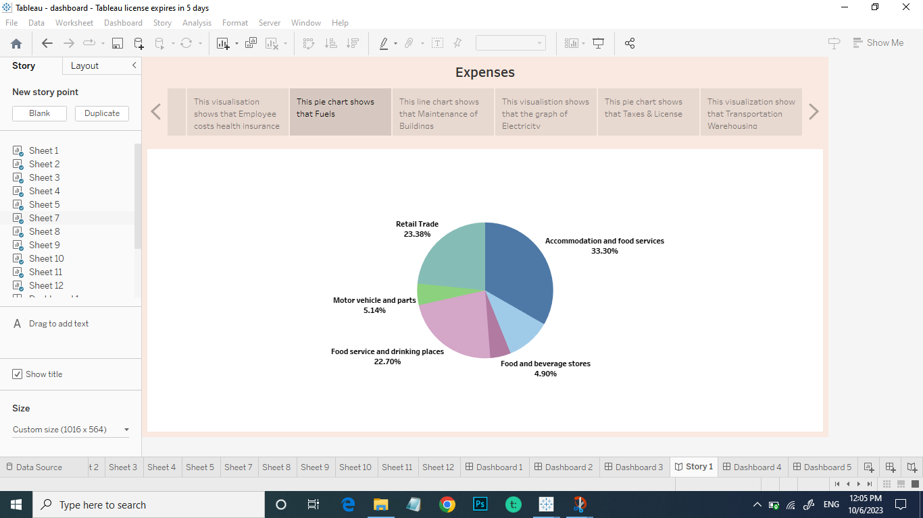

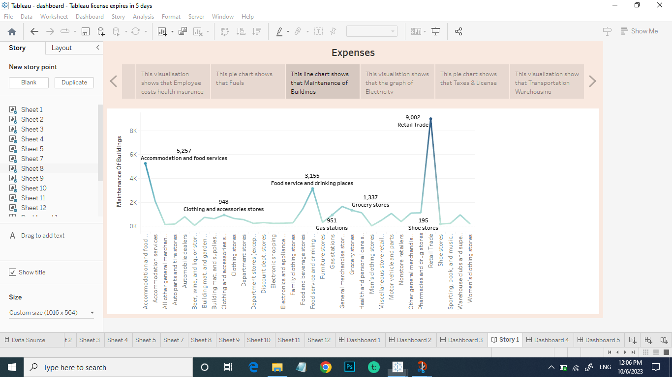

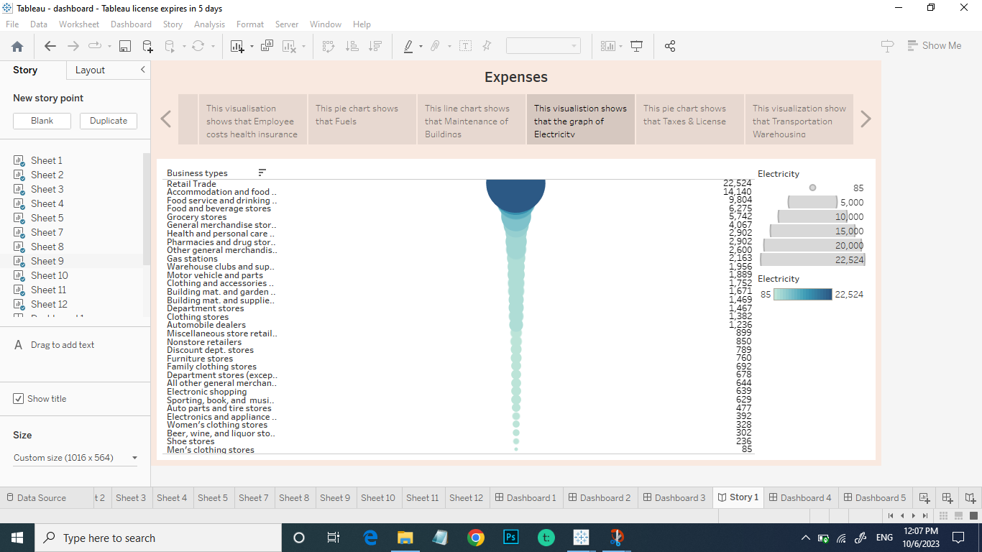

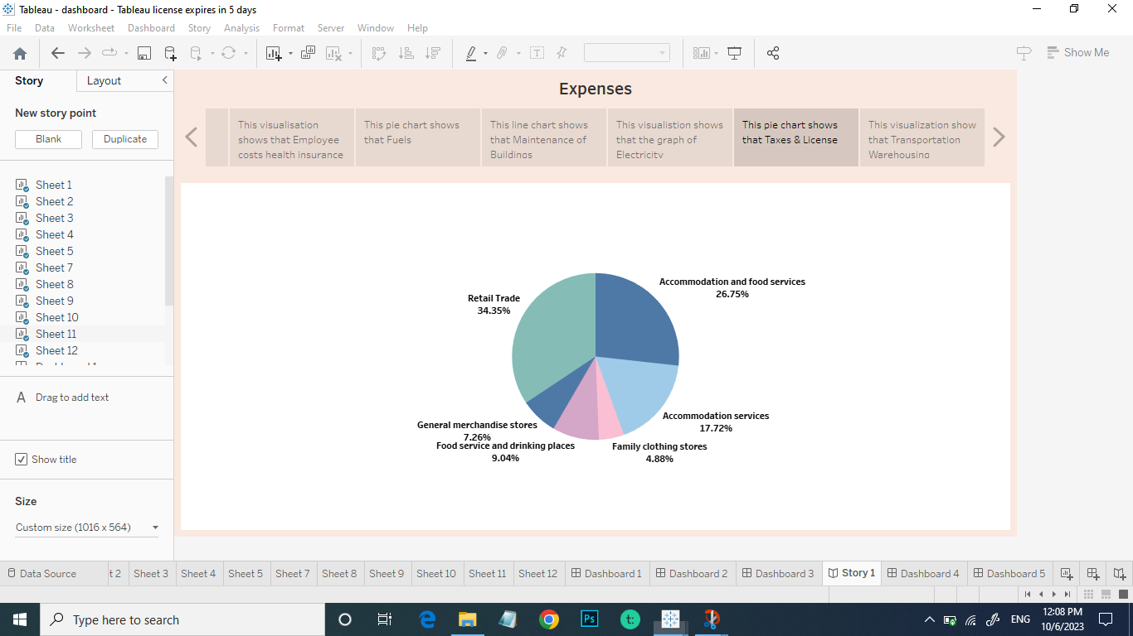

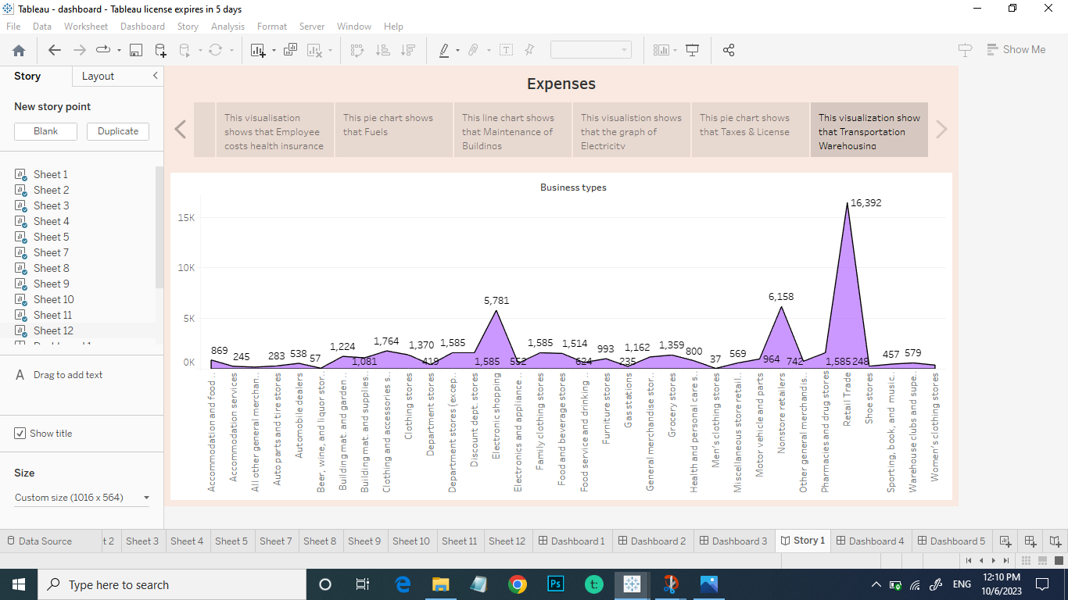

**Advantages**

* Benefits of corporate independence and control
* Mode of living and freedom
* Huge financial advantages
* Individual growth, creative freedom and personal satisfaction
* Tax advantages

**Disadvantages**

* Financial risks
* Issues with stress and health
* Commitment to time

**Applications**

* Zoho expense
* Rydoo
* Quick books
* Emburse spend
* Expensify
* Euerlance
* Fyle
* Mint
* Day-to-day Expenses

**Conclusion**

A business plan conclusion is a summary of a business plan’s strengths designed to convince the leader of the company’s success. Because companies typically business plans to get funding or investors. The conclusion should focus on how the organization makes money and why it is a good investments.

**Future Scope**

* To determine an estimate’s scope, cost analysts must identify the customer’s needs that is, the cost estimator must determine if the estimate is required by law or policy or is requested
* The accuracy of your project estimate is defined by the details presented in your scope of work.
* It provides the inputs so as to forecast future milestones and plan future events.